Assignment

1. Build the current state of Value Stream Map using data above. Highlight rework as part of non-value added time

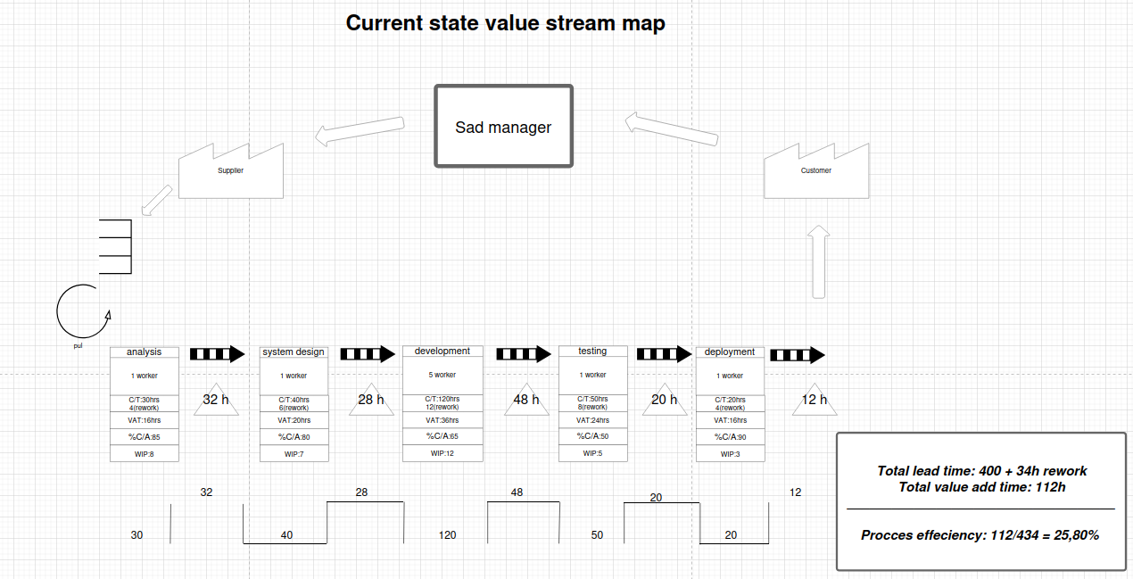

2. Calculate the Lead Time  
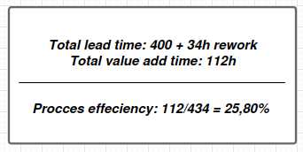

3. Analyze the waiting times and rework at each stage. Which stages have the longest

waiting times and highest rework, and how does this impact the overall process?

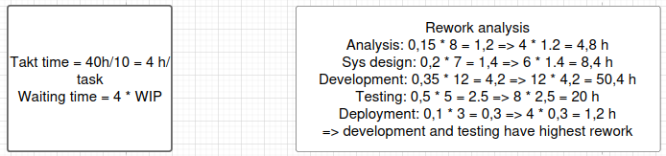

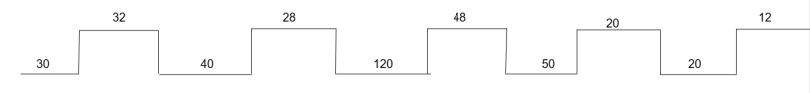

Impact: Rework and bottlenecks significantly increase Lead Time, especially in Development and Testing

4. Focus on the output quality at each stage. Which stages require the most rework, and

how can quality improvements be made to reduce the number of corrections needed?

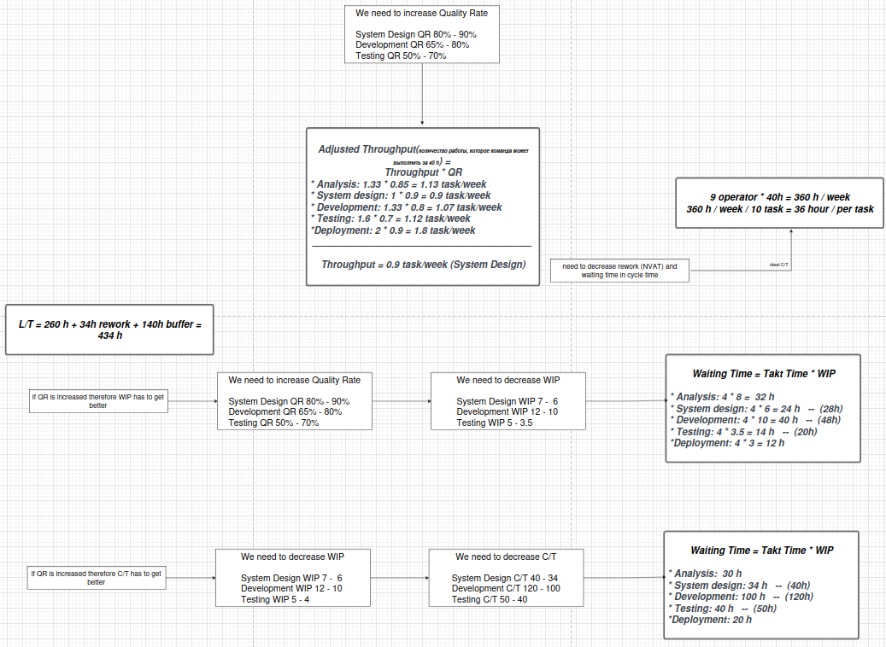

5. Evaluate the current workload (WIP). Which stages are overloaded with tasks, and

how does this impact the overall completion times?

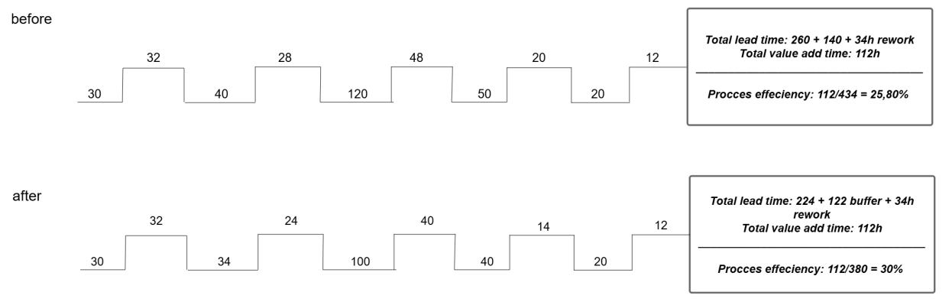

6. Calculate team’s current throughput. For each task and in total. 1 employee work = 40

hours per week. Think twice, how to calculate overall system throughput? You can’t

sum.

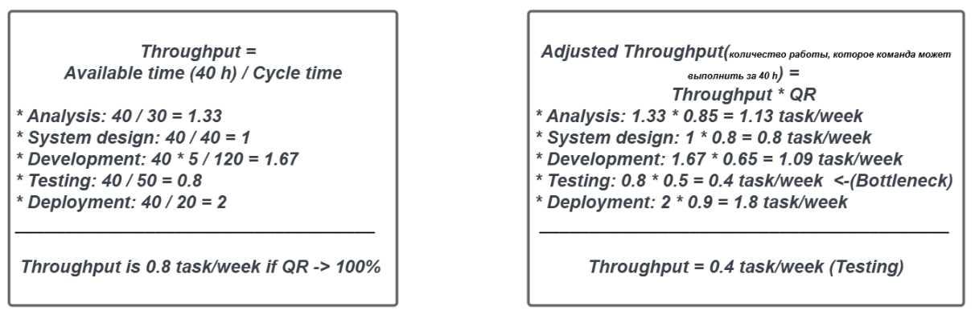-->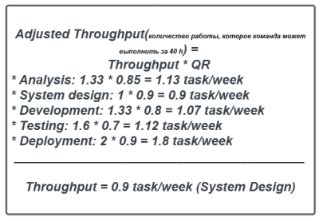

7. Examine the number of employees at each stage. Are there stages that are under-

resourced, causing bottlenecks? How can the team be reallocated to improve

efficiency and reduce delays?

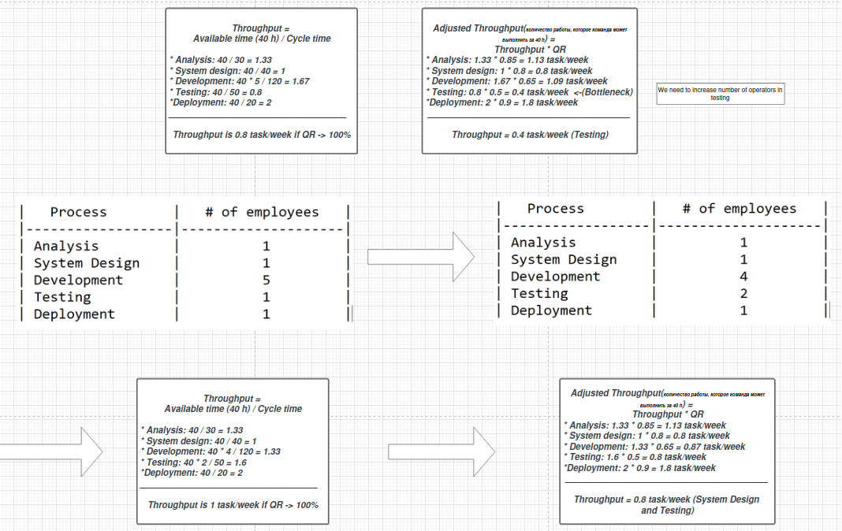

8. Identify non-value-added activities. Look for opportunities to reduce NVAT (such as

waiting, rework) and increase VAT to speed up the process and improve efficiency

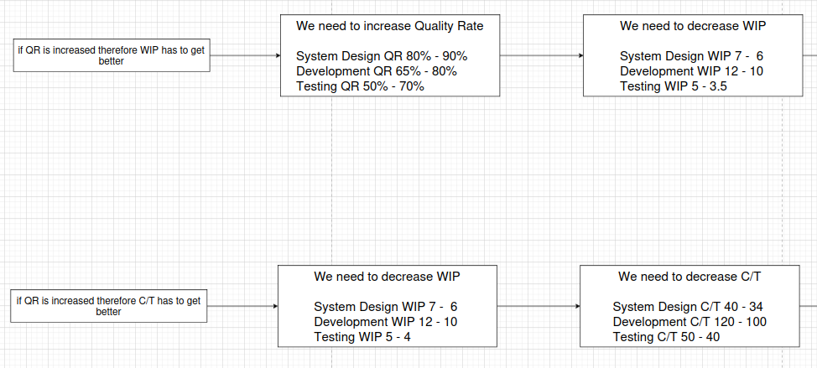

9. What are the major causes of delays, rework, and overloads in the process?

-Low Quality Rate in Development and Testing.

- Bottlenecks in Testing (50% pass rate).

- Miscommunication between stages.

- Overloaded Development team with unclear priorities

10. Propose a future state Value Stream Map (Future State VSM) with suggested

improvements

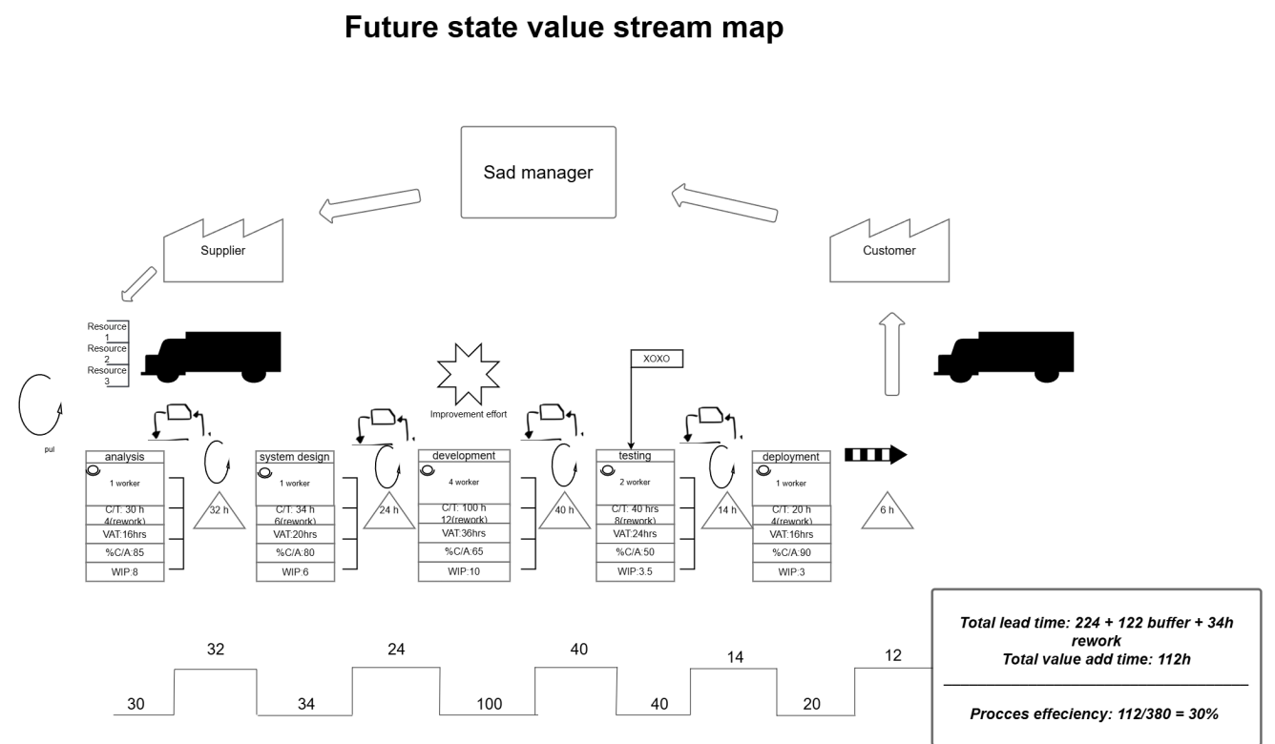

**Kanban**:

Increases visibility into the development process and operations.

Helps identify and eliminate bottlenecks.

Improves the quality of communication between developers and operations engineers.

Accelerates product delivery to the end user.  
Tools:

Jira,

Trello,

Azure DevOps Boards

**Improvement effort** refers to the activities, time, and resources dedicated to making positive changes or enhancements in a process, system, or organization.

Tools: Lean and Six Sigma. Agile methodologies. Root Cause Analysis (RCA)

**Heijunka Box** is a visual scheduling tool used in Lean methodology to level workloads and ensure smooth production flow. Stabilizes workflows. Reduces overproduction and inefficiencies. Enhances predictability and efficiency.

11. Describe your findings and recommendations: What key changes are necessary to

improve the team’s performance?

Focus on Quality: - Invest in training, tools, and reviews to reduce rework

Redistribute Resources: - Allocate employees based on bottlenecks to balance WIP

Automate Processes: - Invest in testing and deployment automation to speed up cycles

Implement Agile Practices: - Use shorter sprints and daily stand-ups to improve communication

Monitor Metrics: - Continuously measure Quality Rate, WIP, and Throughput

-Low WIP

Set WIP limits in Kanban board to reduce the number of simultaneous tasks.

Focus on finishing tasks before starting new ones (Stop Starting, Start Finishing principle).

-Optimizing the Test Cycle

Implement Continuous Integration (CI) and Continuous Testing.

Automate regression testing.

Split testing into parallel phases (e.g., use multiple testing environments).

Automate the handoff of tasks between stages (e.g. through integration of DevOps tools: Jira, Jenkins, GitLab).